Geography (GEOG) 403/704 Spring 2022
Lab Eight
Urban and Land Use Applications
20 points
Name: ________________________
Goal: The purpose of this exercise is to introduce you to the unsupervised classification approach to recognizing broad land use categories using TerrSet/IDRISI and ERDAS Imagine software.
ALWAYS READ THROUGH THE ENTIRE LAB HANDOUT BEFORE BEGINNING YOUR COMPUTER SESSION.

Section I: IDRISI
Note: The images you will be using in this section are 8-bit and 24-bit composites of the green, red, and NIR bands. To see what they look like before you process them, launch them with Display command.
Requirements: In this section you will be filling out two tables and answering one question stated at the end of this section. You will also be turning six files that you create and a WORD file with your question answers.

Golden Gate, CA
- Use the CLUSTER command to create an unsupervised classification from three 8-bit images (GOLDENGATE3, 5, and 7). Leave grey level as 6, and saturation percentage as 1.0. Select the options for a broad classification, and to have six clusters created (use the “set maximum number of clusters option”). Call the created classification file GGCLASS.
- Use the 24-bit composite image (GG_24BIT) and the topographic map sections provided to determine what each of the six clusters is in terms of general groups; water, urban, vegetation, etc. Label the clusters as more specific groups if you are confident in your classifications. Limit the length of your labels to 10 characters. Fill in the following table:

Classification # | General Cluster label | Specific Cluster label | New color for palette
1
2
3
4
5
6
- Use the symbol workshop to create a palette with visually appropriate colors for each of the six classes. Save your palette file as GGCLASS.
- Use the METADATA command to label each of the six classes (legend categories) in the image file GGCLASS with your chosen names. If this is done correctly, you should see these names with the colors you have chosen for them when you view the GGCLASS image with the GGCLASS palette and display the legend.
Copy the following files onto your memory stick to be turned in with the completed tables and answer to question (below). Be sure to label the memory stick with your name and put files in the same folder used previously for this lab.
GGCLASS.RST
GGCLASS.RDC
GGCLASS.SMP

Green Bay, WI
1. Do the same procedure with the files GREENBAY357 and GB_24BIT exactly as you did for the Golden Gate files above. Use the file names GBCLASS for your three final files.
Classification # | General Cluster label | Specific Cluster label | New color for palette
1
2
3
4
5
6
Turn in the following files with the completed tables and question (below).
GBCLASS.RST
GBCLASS.RDC
GBCLASS.SMP

Comparison
Question I-1. Consider the categories you have found in the two images, including any differences in scale, the size of the cities, and the different climates. How accurate would the classification scheme developed for one city be if used in the other? What do you conclude about the limitations of unsupervised classification?

Section II: ERDAS Imagine
Note: Setup the working folder for the ERDAS Imagine program by going to File/Preferences, and enter either “C:\temp\Geog403" or “C:\temp” as the directory for both the “Default Data Directory” and “Default Output Directory”, click “Save” and the “Close”.
Requirements: In this section you will be answering five questions distributed throughout this part of the lab. You will also be turning in two more files (xiso.img and xiso.rrd) that you create. Copy these files to your memory stick, be sure to label your disk with your name and put files in the same folder used previously for this lab..
- Display the image called manaus.img in a viewer as Fit to Frame. This TM scene is from central Brazil.
- From the Main Icon Panel, select Raster and then Unsupervised Classification. This will bring up the Unsupervised Classification (ISODATA) dialog box.
- For the Input Raster file be sure manaus.img is entered. For the Output File enter xiso.img.
- Select “Isodata” Enter 15 for the number of classes (both locations). Leave other setting in this window as they appear. Click the Initializing Options button. Select Principal Axis to remove any data correlation. Change the standard deviations to 2.00. Click Close.
- Click the Color Scheme Options button. Select Approximate True Color radio button. This will produce an average image color for each of your classes as opposed to producing a gray scale output. Click Close.
- In the Processing Options set the Maximum Iterations at a high number such as 25. This may allow your process to take more time, but it will not limit the accuracy described by your Convergence Threshold.
- The Convergence Threshold is the percentage of pixels that do not change classes between successive iterations. Leave this and the Skip Factors as the defaults.
- Click on the OK button. The process status box will appear. You can see the current Covergence and the number of iterations. This can be closed when the job is done.
- From the Viewer Tool Bar click on the Open Layer icon (top left). Select the file you just created xiso.img and click OK.
- Select the Metadata icon and answer the following: Question II-1. Is the data file Thematic or Continuous? Question II-2. How many layers does this dataset have? You can close the Information window after answering the questions.
- You should still have xiso.img displayed in your viewer. From the Viewer Contents Menu right click on the xiso.img file and select Raster/Table/Show Attributes. Question II-3. How many classes are in the classification?
- From the Raster Table Tool Bar click the Column Properties icon. Adjust the order of the Class_Names column by selecting Class_Names from the Columns list and then clicking the Top button.
- Change the Display Width of the Class_Names column by replacing with 10.
- Now select the Color column and click the Up button to make it second in the list. Deselect the Show RGB check Box on the right of the dialog and click OK.
- Scroll up the Attribute Table so that all classes values can be seen. Question II-4. Check the Histogram column. Which class comprises the largest part of the scene?
- You will now edit the Class_Names column and the Color column. You may use the Edit/Undo Last Edit icon (top left) to undo a change, but this will only work for the last edit.
- A way of differentiating pixels belonging to a certain class is to temporarily change their color. Click on the Class 4 color patch and select Yellow. This class stands out in the image as a water class. You can now select a more appropriate color, like Blue. In the Class 4 Class_Names column enter Clear Water.
- Repeat this process for the remaining 14 classes, selecting appropriate colors and names. The following are possible classes, but you are not restricted to these: silted water, shadow, mixed forest, cleared forest, agriculture, urban, sand, roads, bare soil. Question II-5. What type of ancillary data could help you with this classification?
- When you have labeled and colored all 15 classes, select the Save icon and Close the Attribute Table. This will save your classification work within the xiso.img file.
- Turn in your completed xiso.img and xiso.rrd files, along with the answers to the questions in a WORD file.

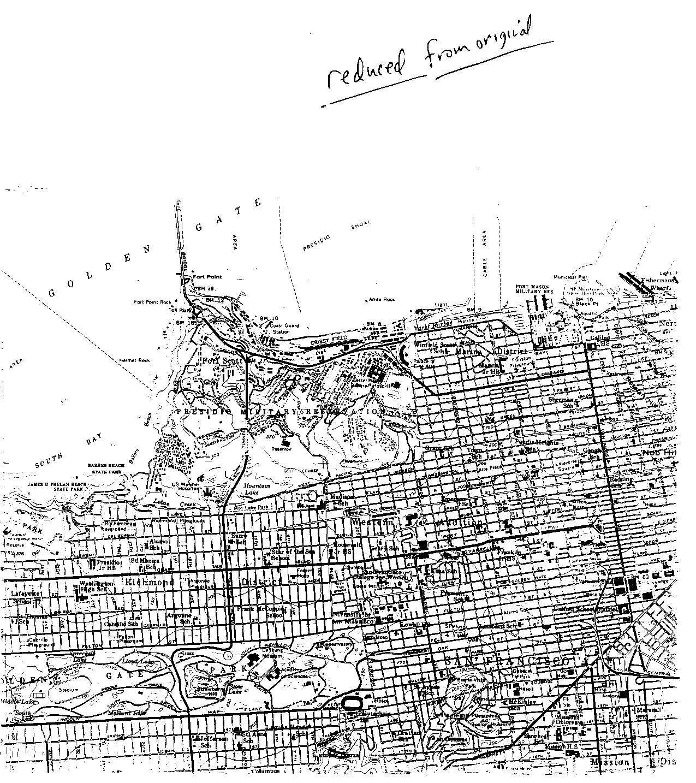
Geography (GEOG) 403
/704
Lab Eight
Geography (GEOG) 403/704 Lab Eight
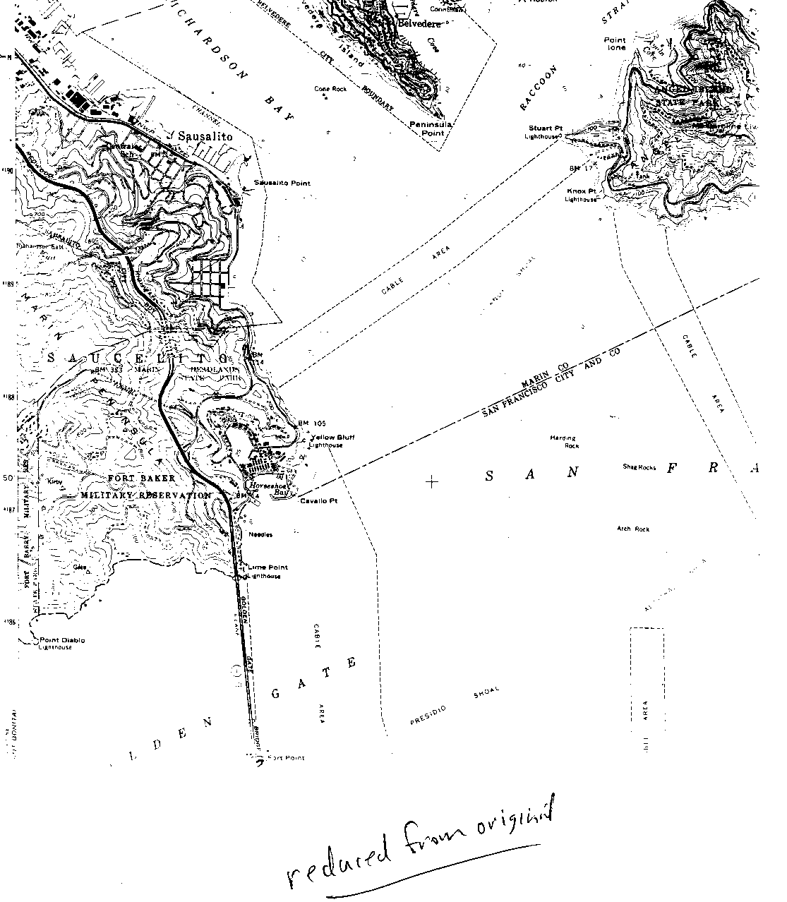
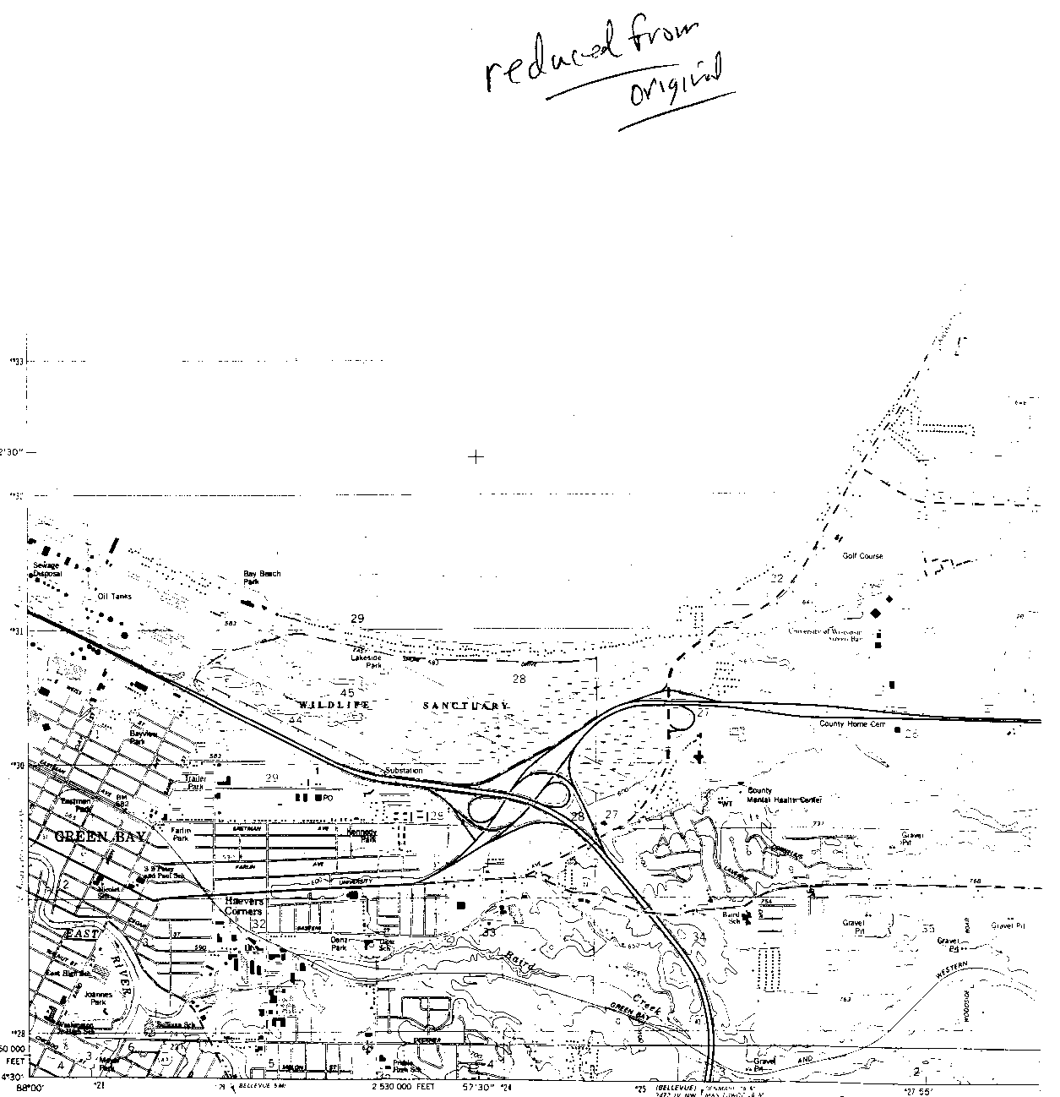
Geography (GEOG) 403
/704
Lab Eight
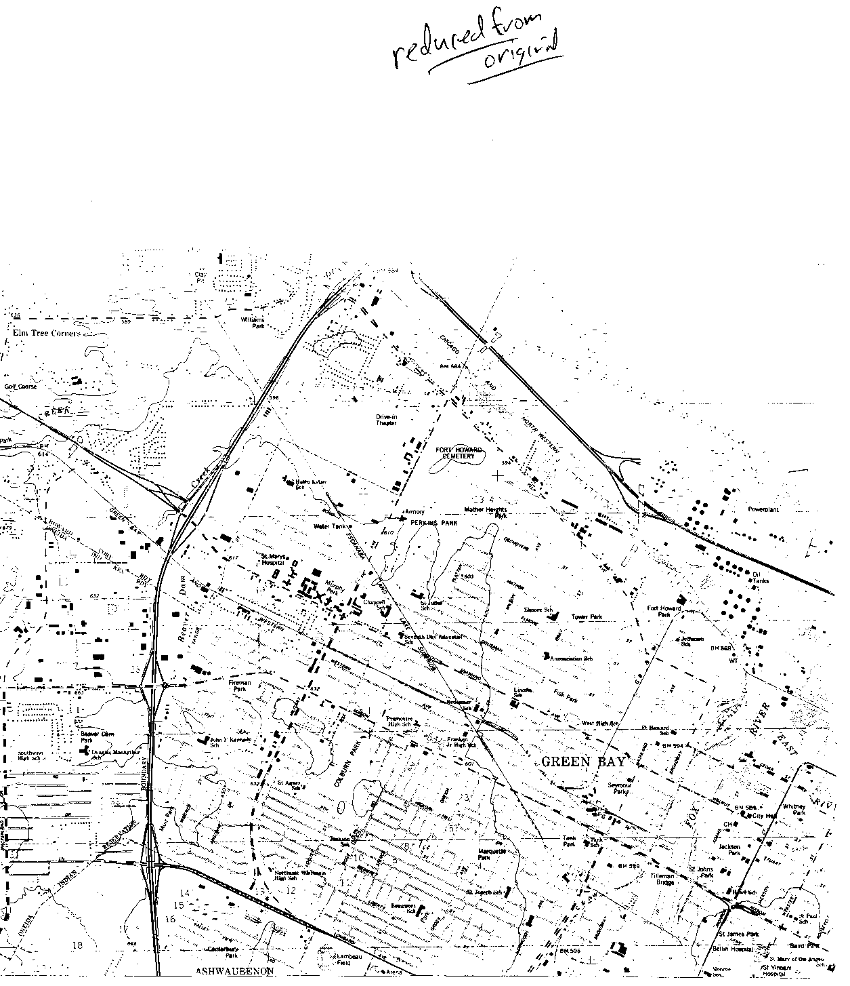
Geography (GEOG) 403
/704
Lab Eight

