Geography (GEOG) 403/704 Spring 2022
Lab Eleven
Geology and Soils Application
15 points
Name: ________________________
Goal: The purpose of this exercise is to introduce you to the use of remote sensing data for identifying different soil and rock types in desert areas. ALWAYS READ THROUGH
THE ENTIRE LAB HANDOUT BEFORE BEGINNING YOUR COMPUTER SESSION.
Requirements: You will be answering four questions (put in a WORD file) and turning in three other files, as done for previous labs.
For this lab you have been provided with images of the Cuprite Mining area in Nevada. These images were obtained with the TIMS sensor, which records information in six different
bands of the thermal infrared. The six bands are designated as CUPRITETIMS1,
CUPRITETIMS2, CUPRITETIMS3, CUPRITETIMS4, CUPRITETIMS5, and
CUPRITETIMS6. The color photograph of the area, available from your TA, may help you to complete this exercise.

Supervised classification
- Use the STRETCH command (histogram equalization option) on the CUPRITETIMS1 image and call the result HISTCUP1.
- View HISTCUP1 using the user defined “REVGREY” palette. The image should look like Figure 1 (without the training sites).
- Using the locations indicated on Figure 1, use on-screen digitizing to record training sites for the six surface classes. You may find it useful to refer back to lab 5 where the same process was used for a supervised classification of land use cover. Digitize at least three areas for each class. Call the vector file CUPTRAIN.
- Run MAKESIG using the six images (CUPRITETIMS1-6) and CUPTRAIN and provide the six signature names from the classes as indicated on Figure 1.
- Use the MINDIST classifier (default options) to produce a classification image with all six surface classes called CUPSUP. Use the CUPRITE palette to view your results.

Principal Components Analysis
- Run PCA on the six Cuprite images (Forward T-Mode and Correlation matrix-Standardized options) and ask for six components to be created. Use CUP as the prefix, so you’ll get files CUP_T-Mode_Cmp1 - 6. Leave the output as “Simplified output”.
- Save the tabular results to a .html file (name it t-mode1_output.html):
Question 1: What percentage of the variance is explained by the first component?
- Run STRETCH (linear option) on CUPCMP1 to produce SCUPCMP1.
Question 2: How similar are the images HISTCUP1, SCUPCMP1, and CUPSUP in terms of spatial regions they allow you to identify?
Question 3: What do the results of the PCA tell you about the similarity of the six TIMS thermal bands?
Question 4: Given that PCA takes more time to run than STRETCH, and a supervised classification like MINDIST takes much more time than either of the other analyses, was the amount of new information gained worth the time invested?
Turn in the following files along with the PCA .html output file and answers to the questions (in a WORD file).

CUPSUP.RST
CUPSUP.RDC
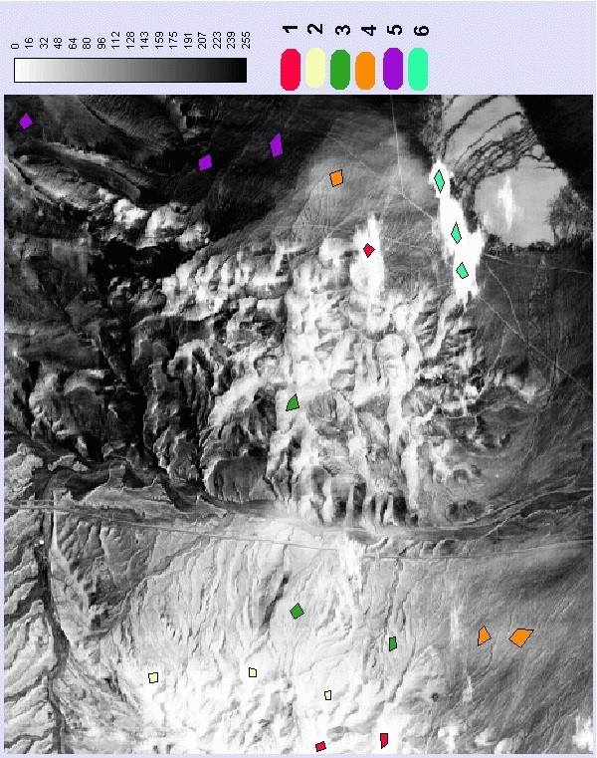
Figure 1: 1 = Tb Basalt; 2 = Ch h. Formation; 3 = Ts Tuff; 4 = Qal Alluvium; 5 = Ttc Tuff; 6 = Water

