- My project is to make a stable living "house" for insects but mainly bees. I choose bees as my insect because as humans we really need bees to live. Without them we would not live because they make it possible for us to have food. Making a house for them would help them be able to survive in many different weather conditions that may occur.
- Over the last few years the bee population has been declining at a steady pace which is not only bad for bees but as well as us as I previously mentioned. Many people mistaken bees for wasps but the two are very different in how they work. Wasps are around just to sting people. Not much good comes from them. While bees can sting but they die after one sting then because they are not meant to sting but to pollinate flowers and crops.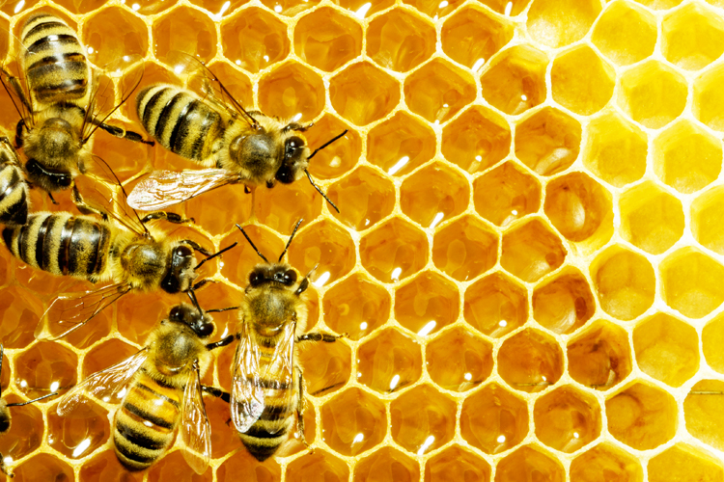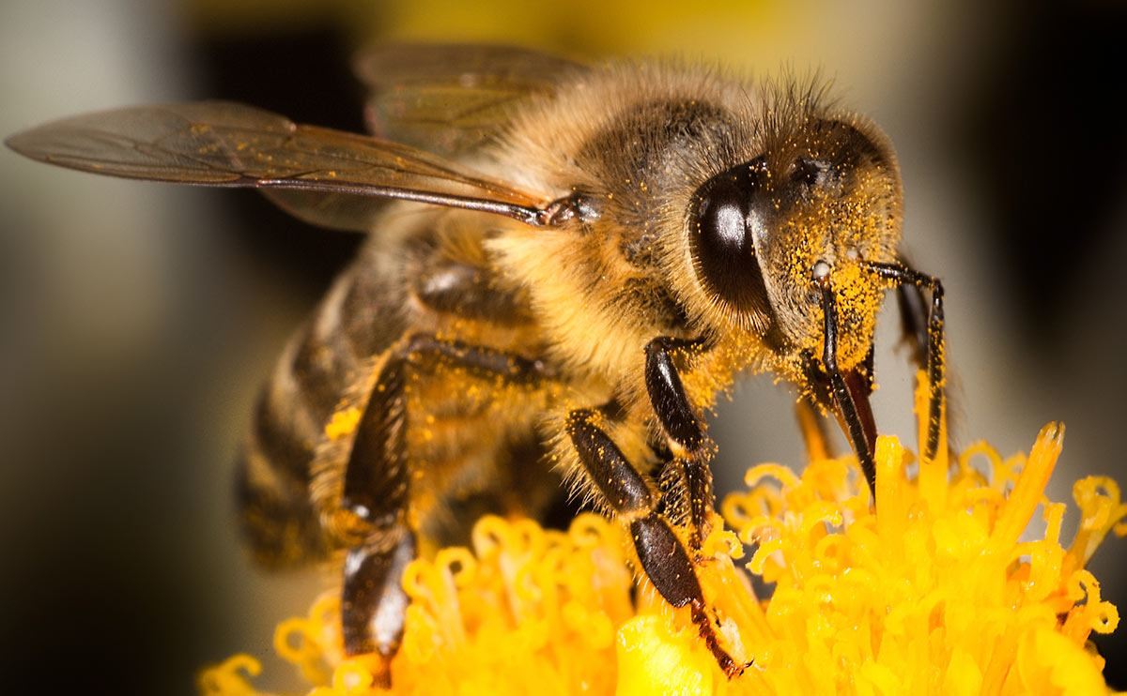
- My sketches started with my piece being hollow and there being two. One for bees and one for butterflies. My piece also ended up being much smaller because of board sizes and what I was able to get ahold of. For me the most important part though it that the piece itself looks like a beehive itself for the bees and to have an interesting shape.
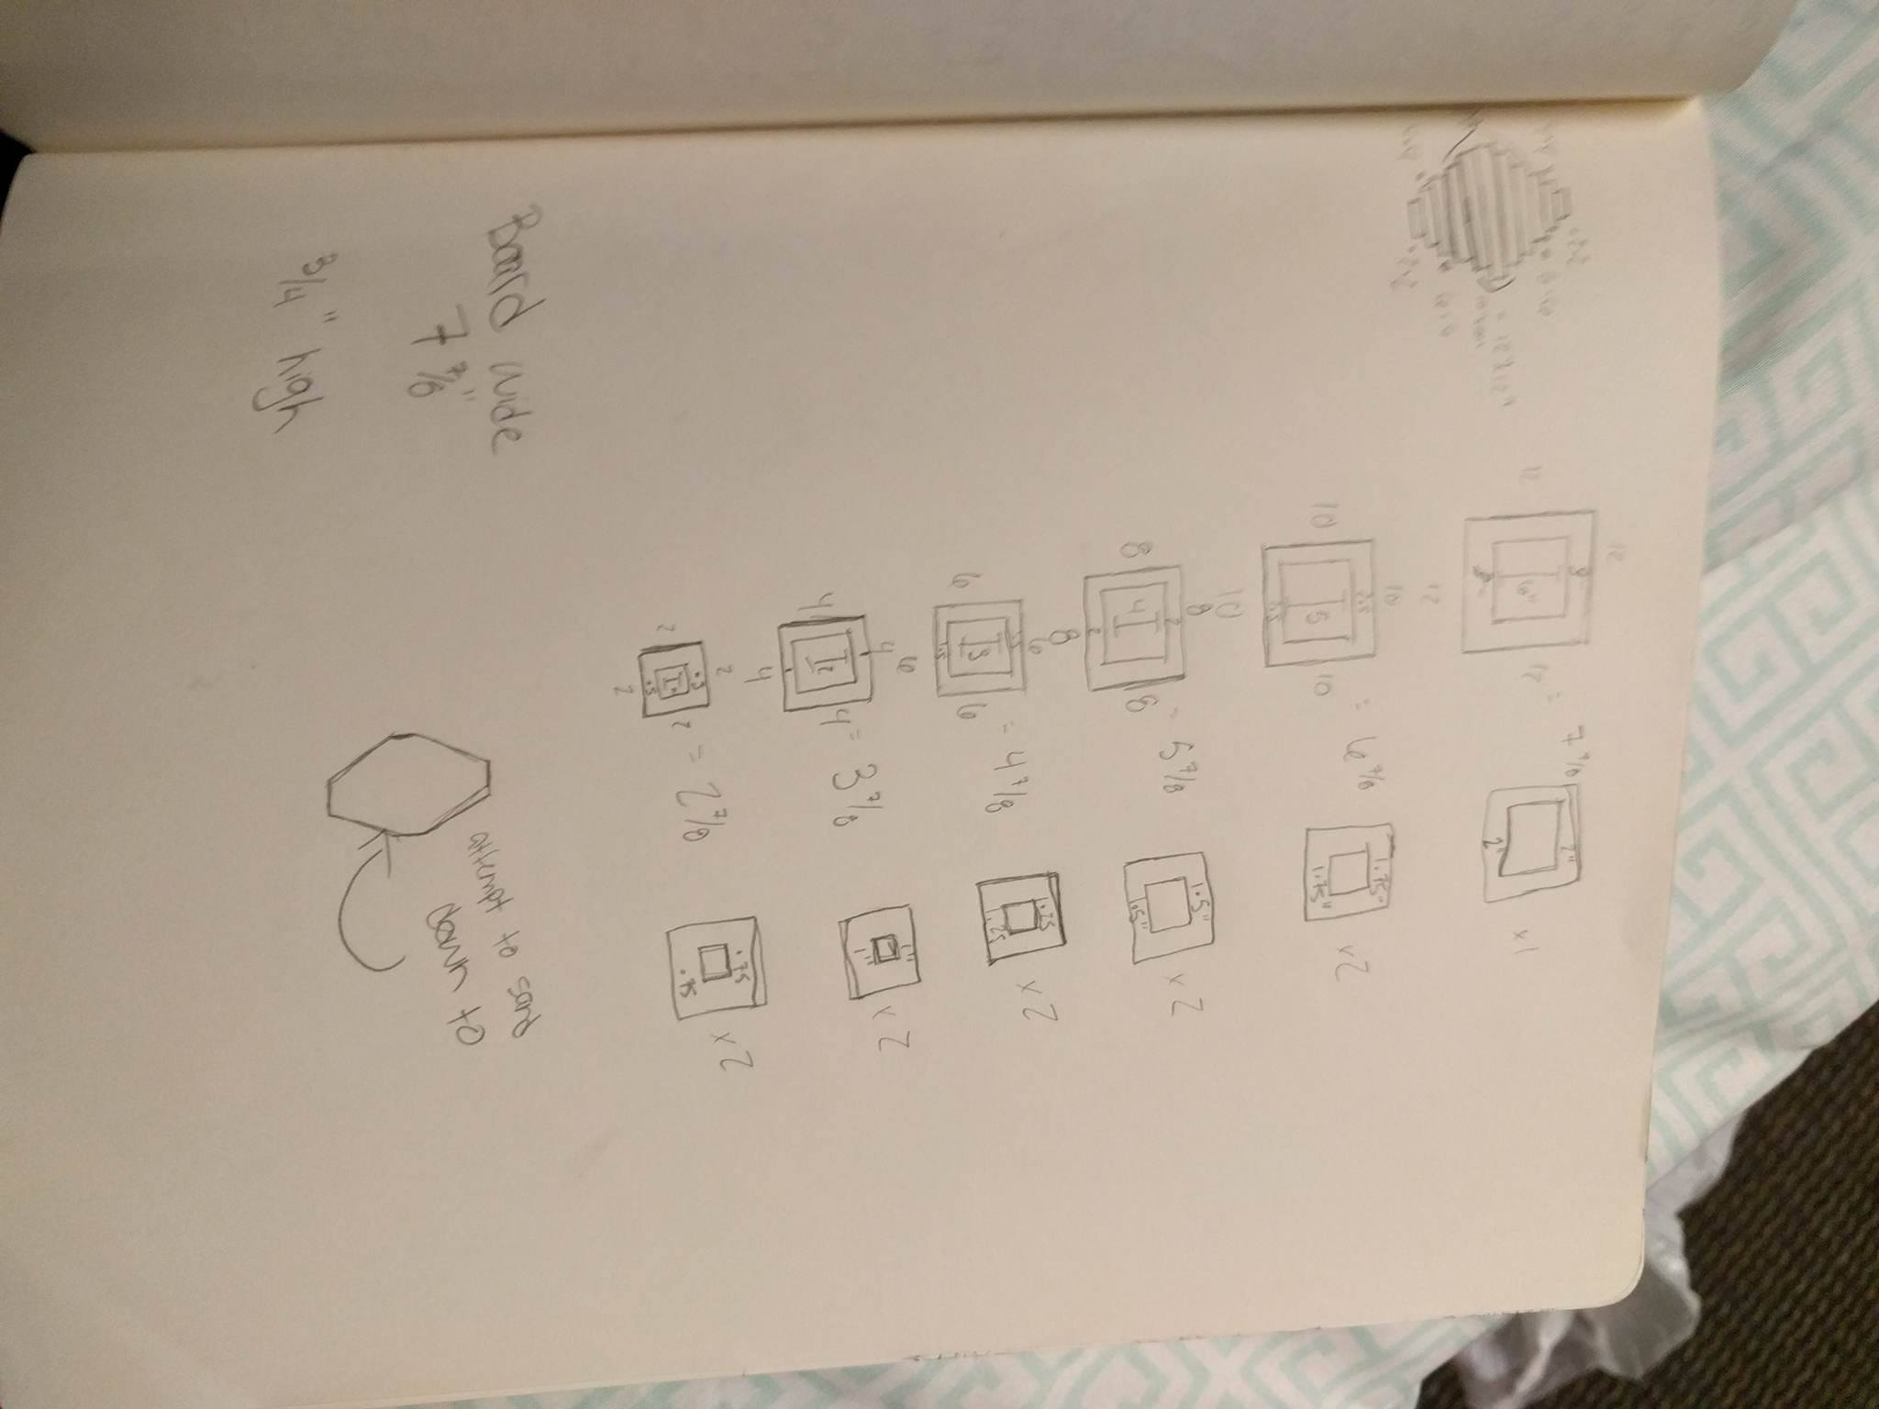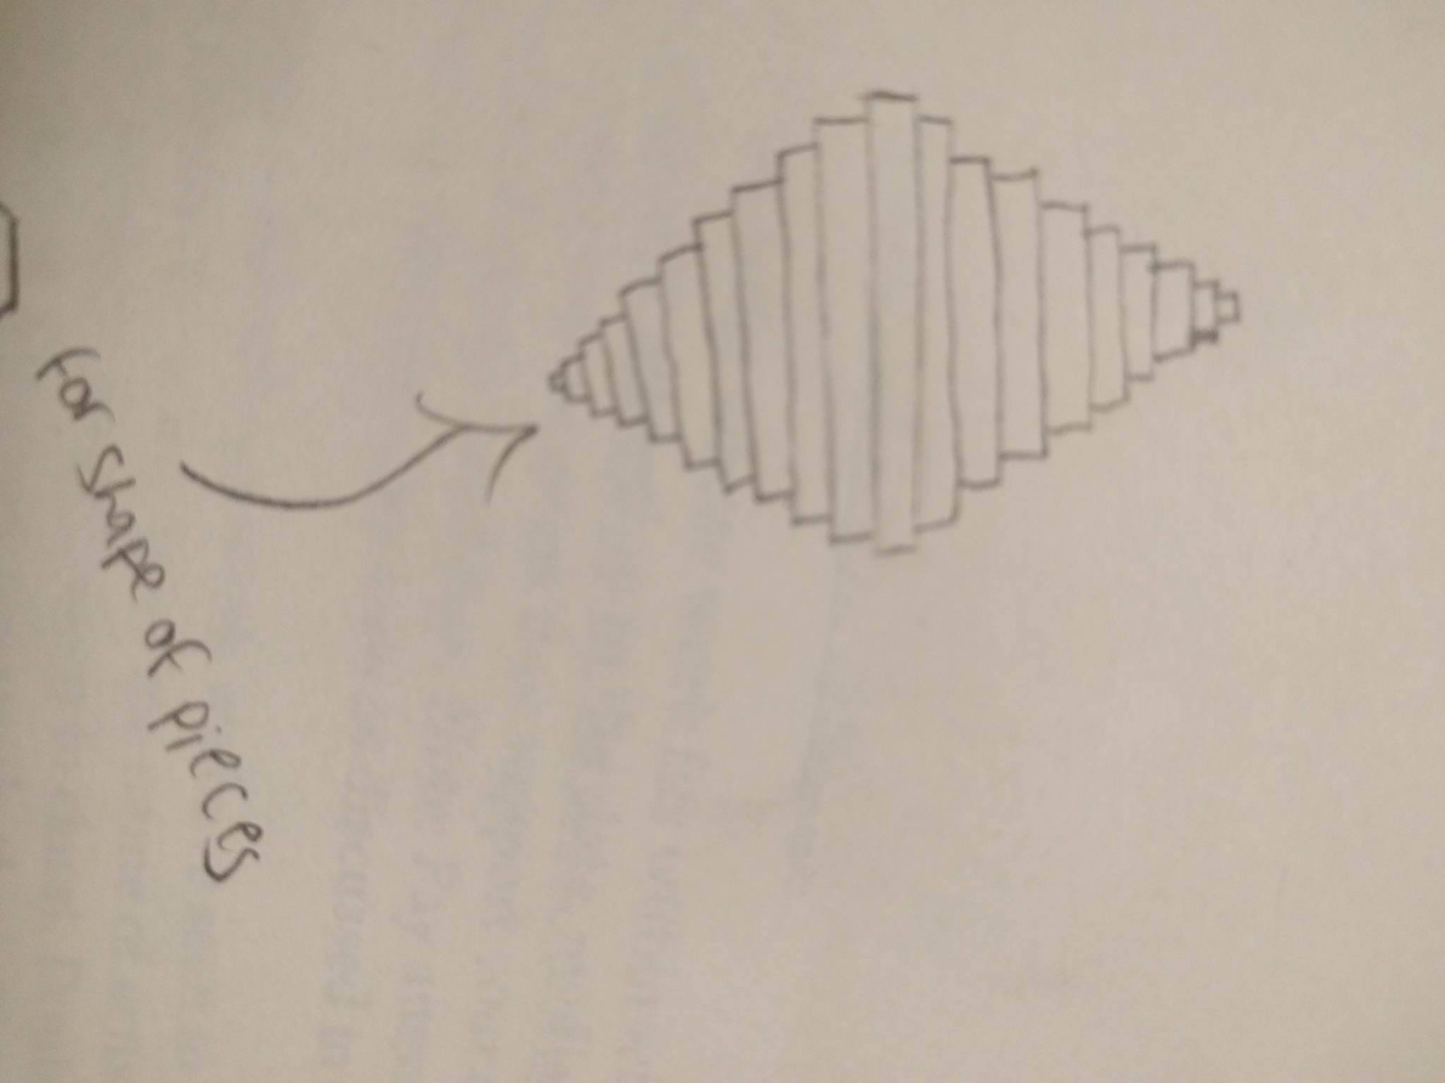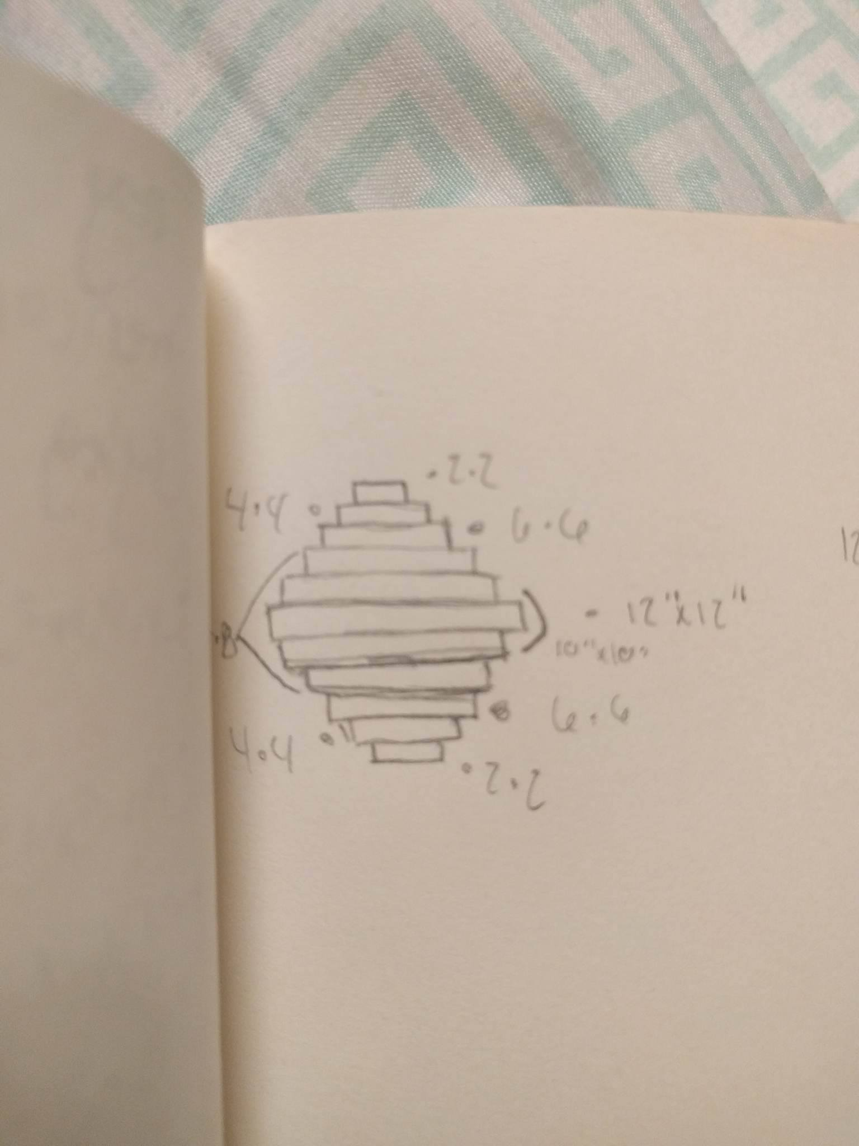
- I had a small cardboard model but the thing itself became all wet from walking in the rain and I did not think I would need it anymore because I had such detailed drawings and precise measurements.
- 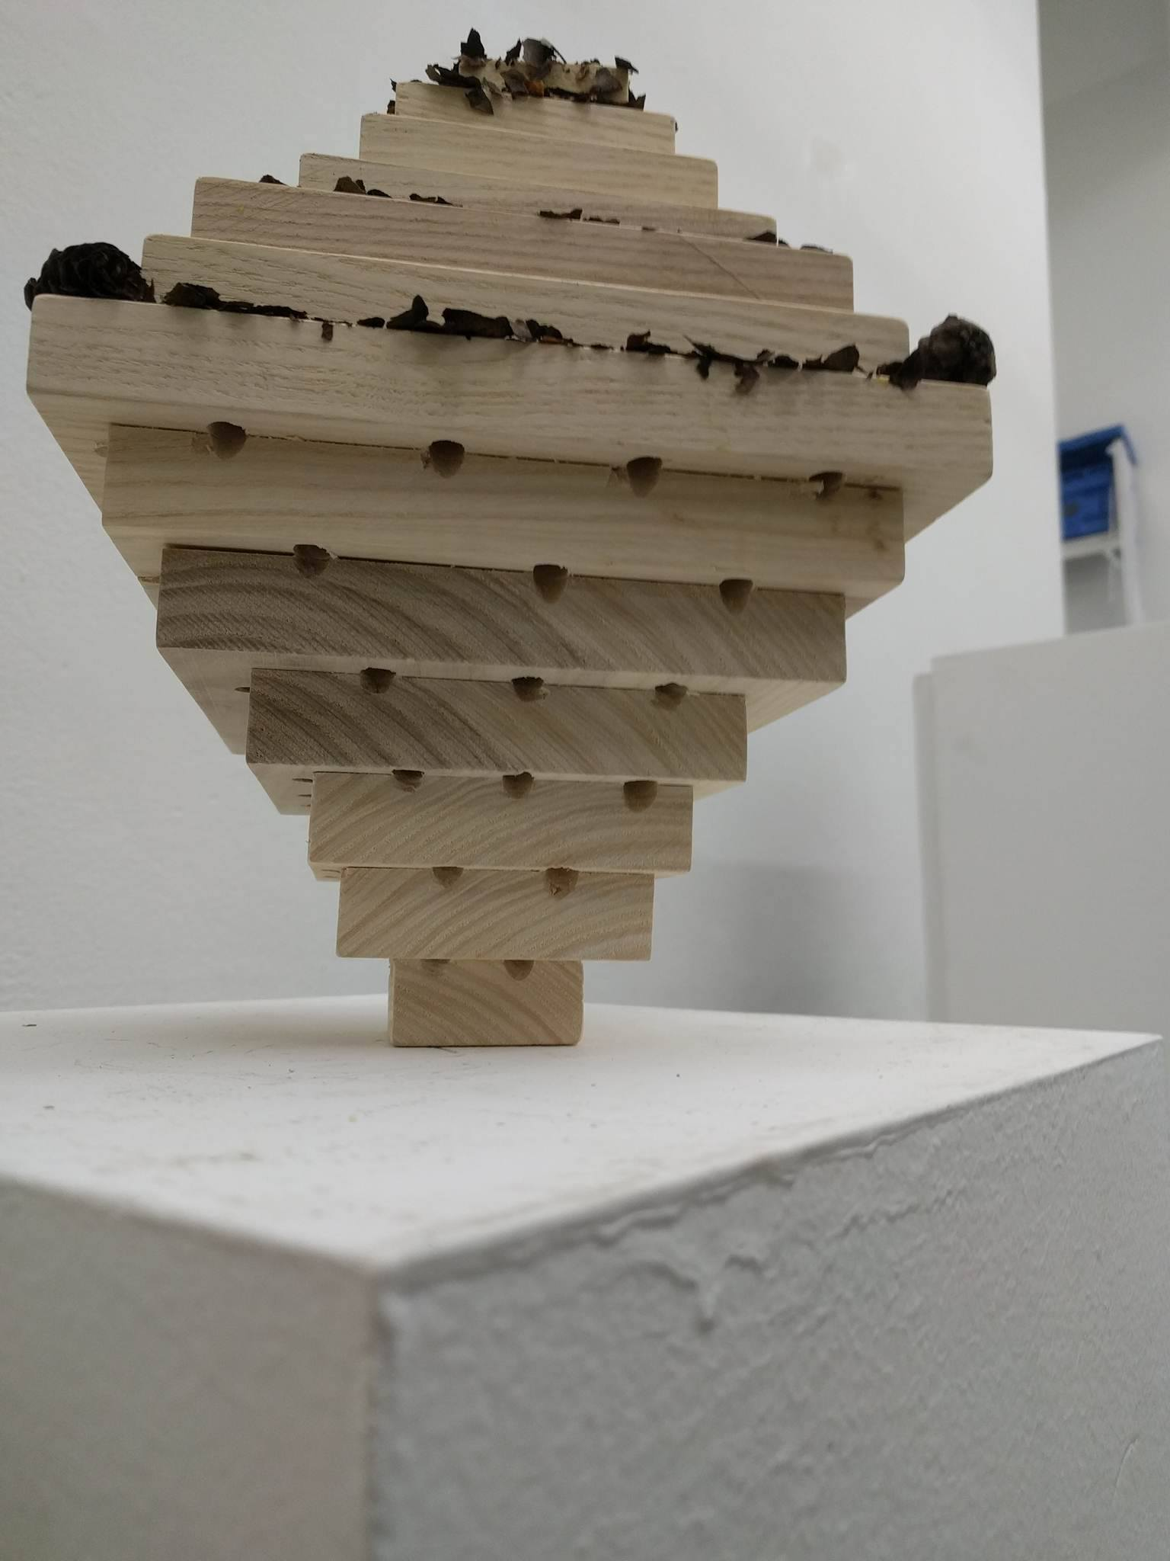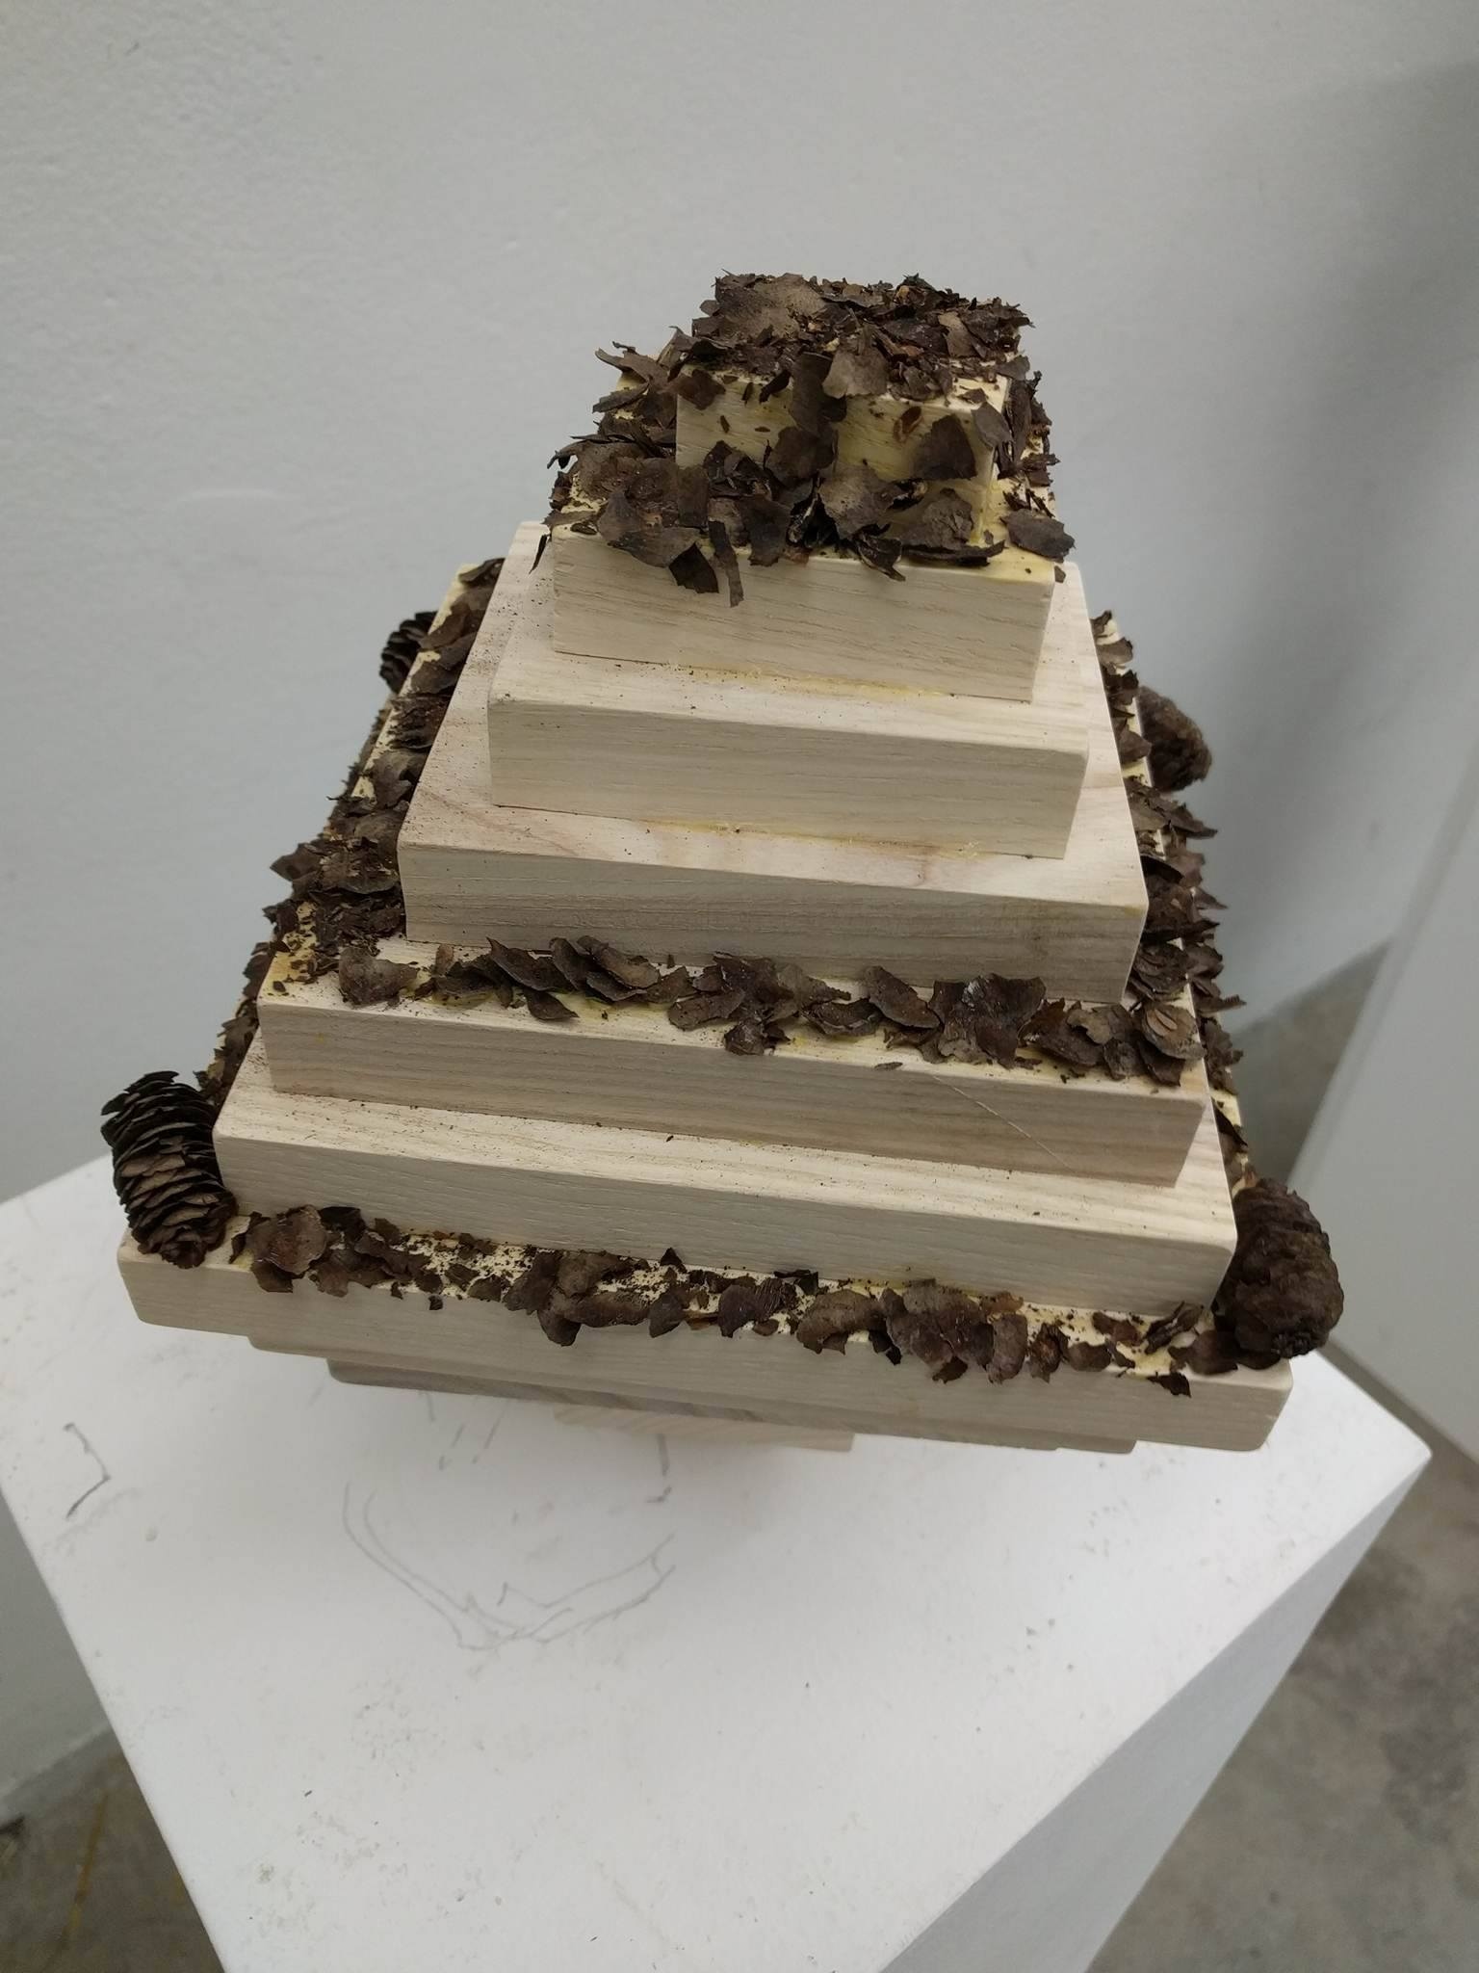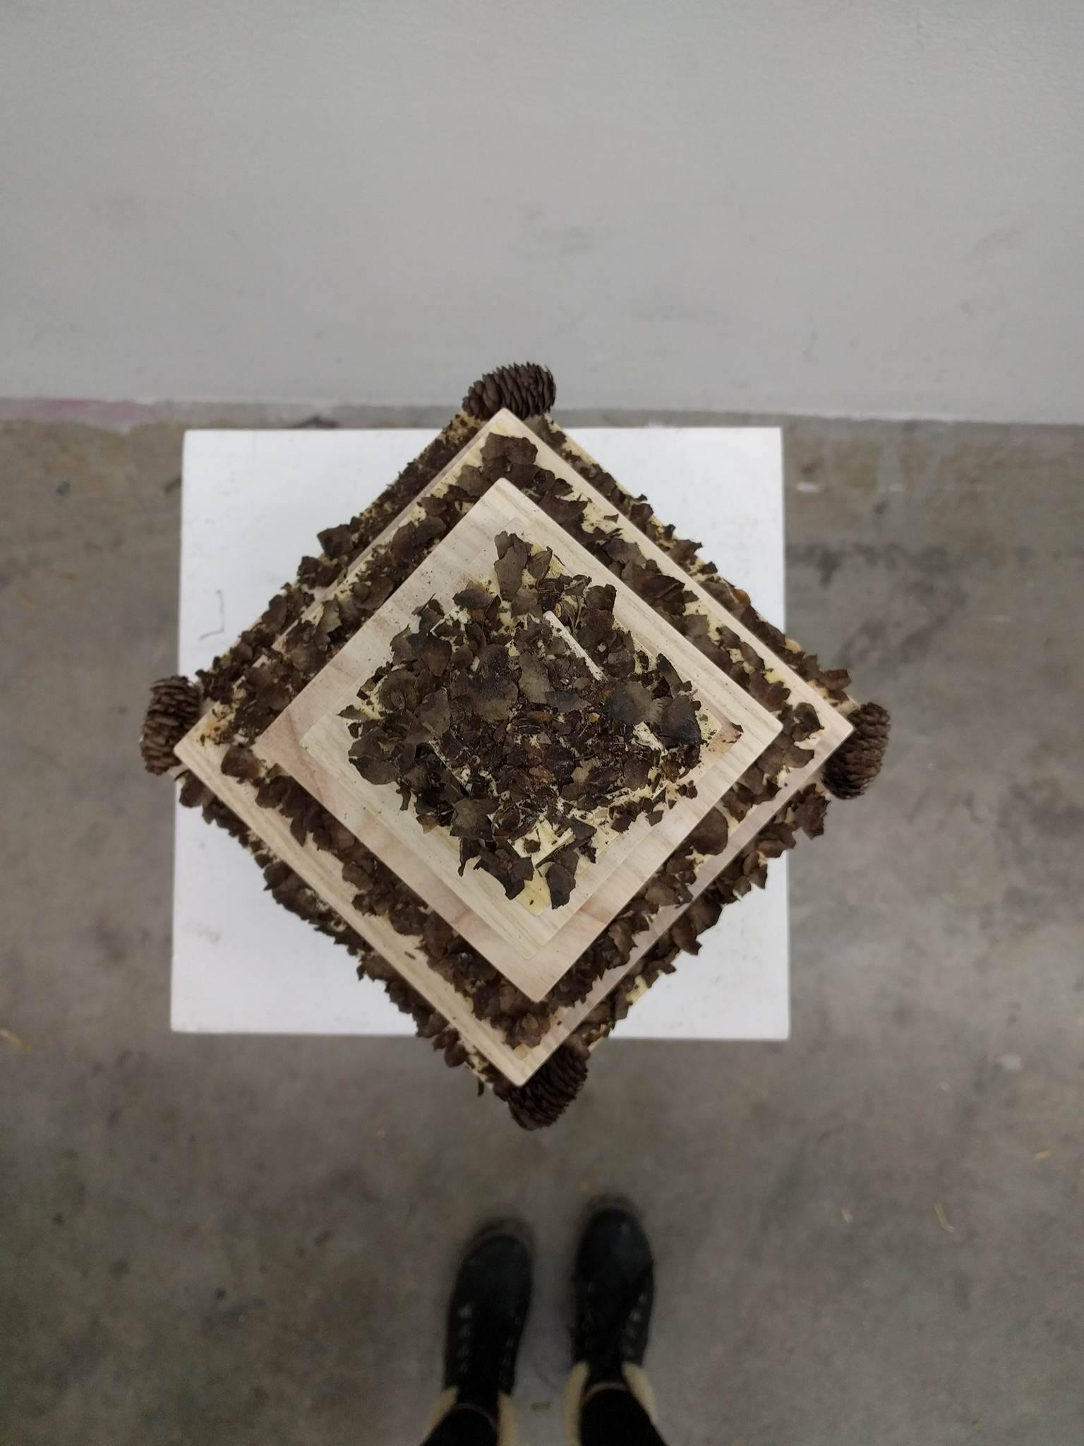
- My final thoughts of the piece was that it is not my favorite piece by any means. I really did not enjoy building it because I will never see it again. The fact that it is outside though for the public made the thoughts of my piece interesting though.

