January 16, 2012

Manual for Using StarFAST TM Software

Marshall Lev Dermer and Corrine Kirsch

University of Wisconsin – Milwaukee

mailto:dermer@uwm.edu

Contents
INTRODUCTION 2
THE PROGRAM 3
Using the Program 3
Responding and Scoring 6
Other Options Besides Scoring Responses 7
Daily Practice 8
Summary Window 8
Graphing Your Data 9
Mastery Criteria 9

INTRODUCTION

Starfast software is more than an electronic flash-cards program because it has a timer that calculates rates of correct and incorrect responding. Considerable research indicates that rate measures of learning are superior to a percent correct (accuracy) measure. A most dramatic demonstration of the difference can be found here:

http://www.binder-riha.com/Bucklin_Dickinson_Brethower.pdf .

In this study students trained to acquire basic skills until achieving either: accuracy (100% correct responding), or fluency (correct and rapid responding). Later students applied these skills. The accuracy group’s application of these skills dramatically decreased with time since training, but not so for the fluency group. This is illustrated in the figure below, from Bucklin, Dikinson, and Brethower, that plots accurracy as a function of group (circles for fluency training, squares for accuracy training) and, frequency of testing (filled in symbols for testing every two weeks; open symbols for testing every four weeks).
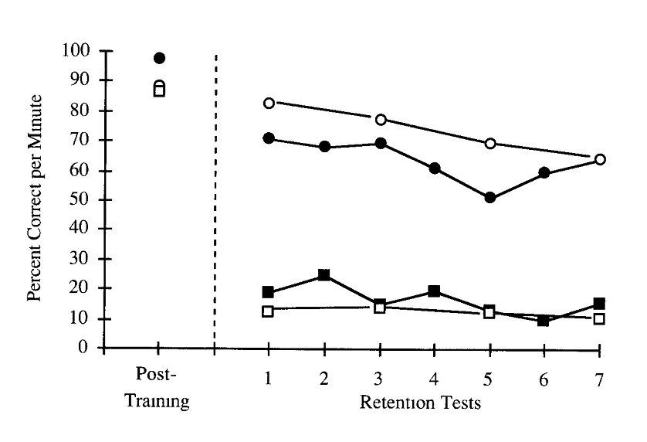
Not that immediately after training all the groups were about as accurate but beginning two weeks later the accuracy group was scoring about 18 percent correct! The fluency group scored very much better for weeks.Worth noting is that retention tests were administered every two weeks. Worth considering is that accuracy is the major measure of learning in American education.

You can discover more about fluency training and related issues here:

http://www.precisionteachingresource.net/15.pdf

THE PROGRAM

StarFAST produces fluency, accurate and rapid responding, by providing learners with lots of practice and feedback about their rate of correct and incorrect responses per min. The software calculates these rates and learners should plot these rates so they can see if they are learning. If they are not, then learners ought to modify the training procedures. StarFAST has been used to teach students to eliminate needless words and how to decline German articles. The illustrative material below derives from several of these versions of StarFAST.

Using the Program

Install the program on your Windows-based computer. To enter the program, double-click the icon on your desktop. When you first activate the program a window like this will open:

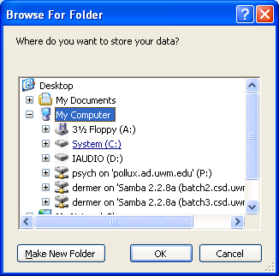

that allows you to specify where your data folder will be stored. We recommend “C” as noted by the arrow above.

Select the OK Button. If there is no data folder here then this box will appear.

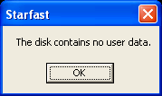

Select the OK Button and enter your name in this window.

When you select “C” or some other location, the software automatically creates the “data” folder at that location as illustrated below.

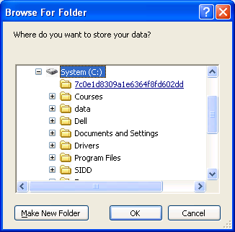

When you next use the software on the same computer and select the same location for the data folder, this window should appear.
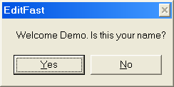

If instead, this window appears:

you have not selected the same location as before. This could be a serious problem because it is best to store data in just one folder. So, under this circumstance close the window and restart the software.

If you select Yes on this window:

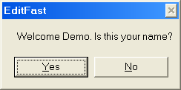

then the Modules Window will appear:
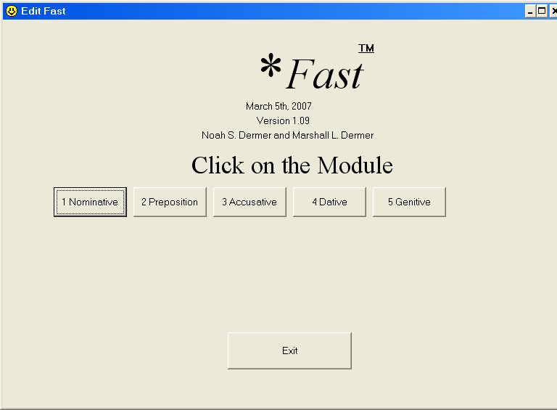

and you should select the appropriate module. Note well, that the modules are completed in numeric order.

When you select a module the Session Window will appear. Below is the Session
Window for the 1 Nominative Module:

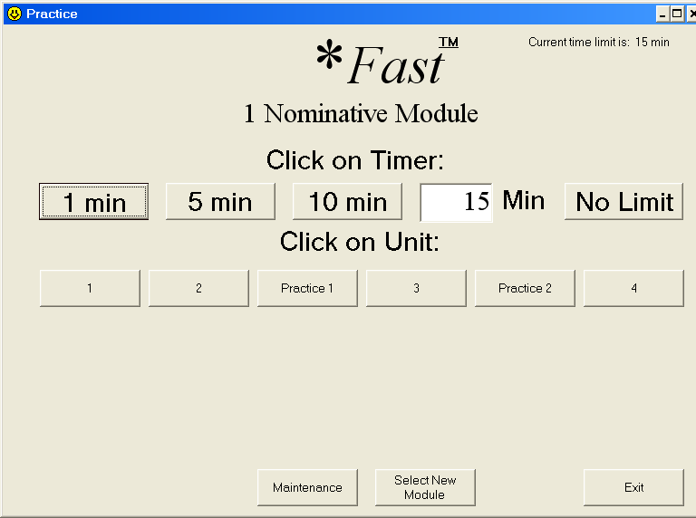

Next select a session duration by clicking one of the Timer Buttons or by typing a duration. Then click the appropriate Unit Button to begin the session. Note well, to complete the units as ordered from left to right: Unit 1, Unit 2, Practice 1, Unit 3, Practice 2, and Unit 4.

Responding and Scoring

When your session begins, a window will appear with instructions and text. Here is such a window:
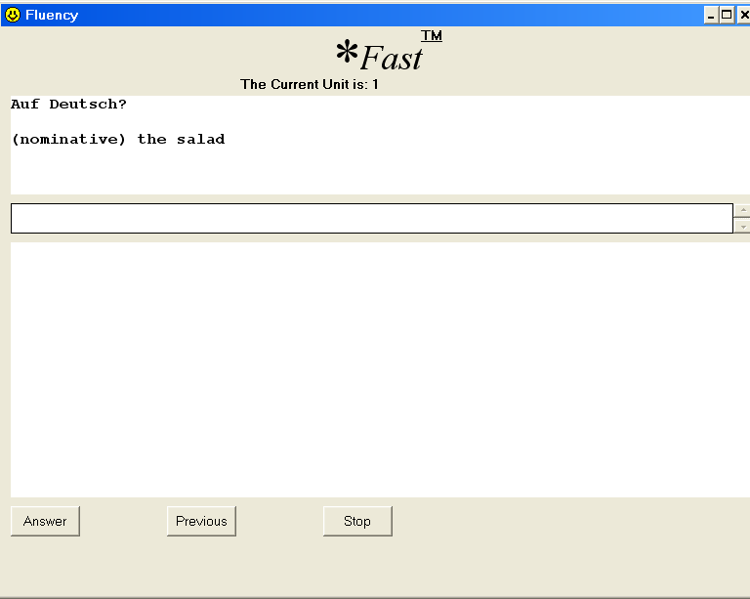

Read the instructions and say or think the correct response as quickly and accurately as possible, then click the Answer Button. The answer will appear in the bottom window.

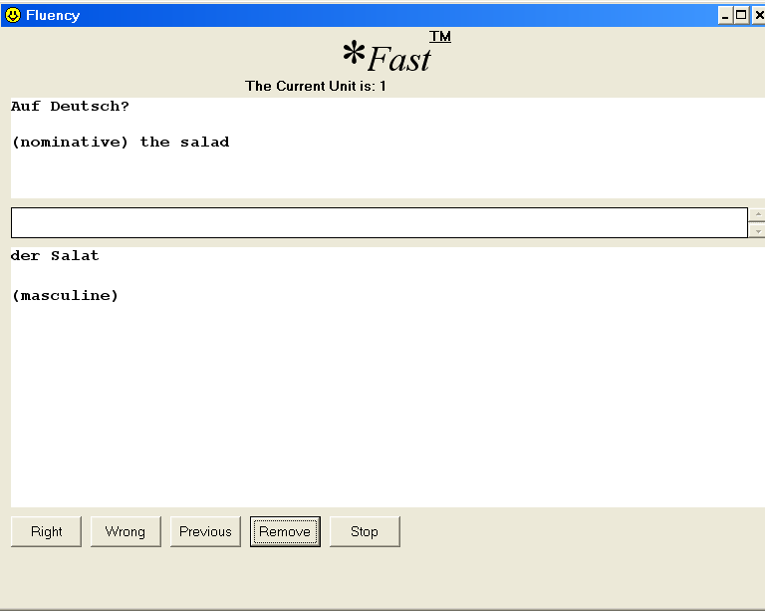

If your response matches the answer, click the Right Button. Otherwise, click the Wrong Button. On clicking either button, the program will code your response and present the next frame. Note: Click the Right or Wrong Button only once! Double-clicking will present the next frame and answer.

In the answer window, below the correct answer, some material may appear in parentheses. This parenthetical material is only informative. Do not respond with the parenthetical material.

Other Options Besides Scoring Responses

If a particular frame is consistently difficult, you may click the Remove Button on the Answer Window to temporarily remove that frame from the unit. However, later you will need to add all removed frames, as you must be able to respond correctly to all frames in a unit to master the unit. You can add those frames back by choosing the maintenance option and deleting the "skp" file that corresponds to the unit from which you deleted frames.

At any point during a session, for whatever reason, you may also click the Previous Button to return to the previous frame. You may also click the Stop Button to immediately end your session. Your session will otherwise automatically end at the time you designated and present the Summary Window.

Daily Practice

It is best to practice for 20 mins per day. You may complete the 20 mins at one session, or you may complete several shorter sessions throughout the day (for example, two, 10-min sessions; four, 5-min sessions, etc.).

Summary Window

When a session ends, the Summary Window will display your session’s data: 1) the aim for the unit, 2) the number of frames remaining, 3) your number right per min, 4) your number wrong per min, and 5) your session’s duration.
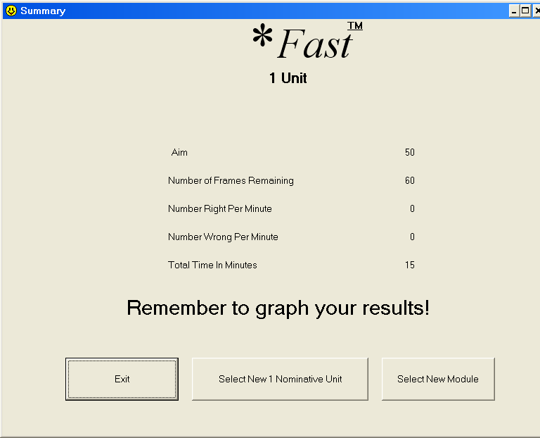

- The aim for a unit is the number of correct responses per min that you should reach before advancing to the next unit. The aims are based on a 1-min timing and assume no incorrect responses.

- The number of frames remaining refers to the number of frames in that unit minus the number of frames you removed.

- The number right per min refers to the number of correct responses per min.

- The number wrong per min refers to the number of incorrect responses per min.

- The session time refers to the session duration that you chose.

You can record and graph these data, if you wish, after each session. These data will also be stored on your USB drive or other storage device that permits comparing the computer’s records with yours. For this reason, it is important to not destroy the data folder or lose the storage medium.

Graphing Your Data

When you are practicing, you are free to select a session’s duration, so the duration of a session may vary across sessions. Indeed, your rates of responding will vary with session duration. Very long sessions are like marathons and test endurance; very short sessions are like sprints and test speed.

However to assess progress, use a 1-min session. At the end of a day of studying conduct a 1-min session with your current unit and graph the data where successive days is marked of the graph’s abscissa is. Actually, a Standard Celeration Chart has been developed for plotting data along with conventions for using the chart. More information can be found here:

http://precisionteaching.pbworks.com/w/page/18240972/FAQs—about%20the%20Standard%20Celeration%20Chart

Here is a nice article with examples of corrects(dots) and incorrects (Xs) plotted on Standard Celeration Charts:

http://www.binder-riha.com/Fluency_Coaching_Poster.pdf

Mastery Criteria

If all is going well, as you practice your rate of corrects (rights) will be increasing and your rate of incorrects (wrongs) will be decreasing. Furthermore, this progress will be occurring with all of a unit’s frames present.

Examine the data from the Summary Window to determine whether you have mastered a unit. To master a unit:

- all the frames in the unit must be present,

and

- your rate of rights/corrects must reach or exceed the unit’s aim
with no wrongs/incorrects for a 1-min session.

When you master a unit draw a vertical line on your graph to indicate that you have begun a new unit.

If you find that you are not making progress as indicated by your rates not much changing from day to day, then you need to change your instructional approach. You might, for example, temporarily reduce the number of frames in unit; or schedule more sessions of short duration (say four, 5-min sessions) rather than one long session (20-min) per day.

