Effect of Time Scale of Streamflow Time Series
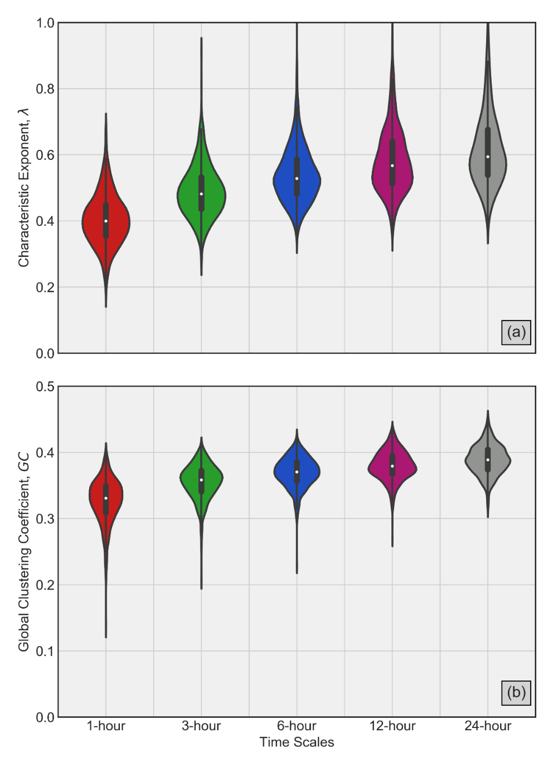
Figure A1: Violin plots of λ and GC across five time-scales of streamflow time series in (a) and (b), respectively using resampling approach. The solid white dot inside each violin represents median while the thicker solid line inside represents interquartile range (75th percentile – 25th percentile). Clearly, a systematic transition toward stochastic behavior is demonstrated by increasing values of λ and GC as time scale increases from 1-hour to a day.

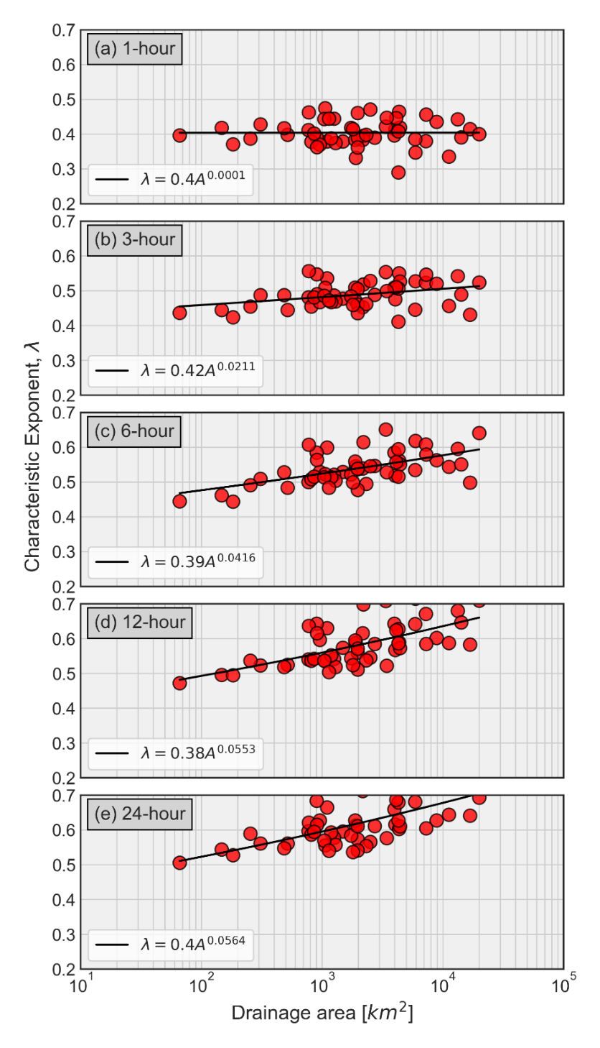
Figure A2: Spatial dependence of λ across five timescales obtained from Figure A1. (a) 1-hour, (b) 3-hour, (c) 6-hour, (d) 12-hour, and (e) 24-hour. The resampling approach demonstrates that with the increasing time and basin size, λ shows systematic increase, and hence the transition toward more stochastic streamflow fluctuations.
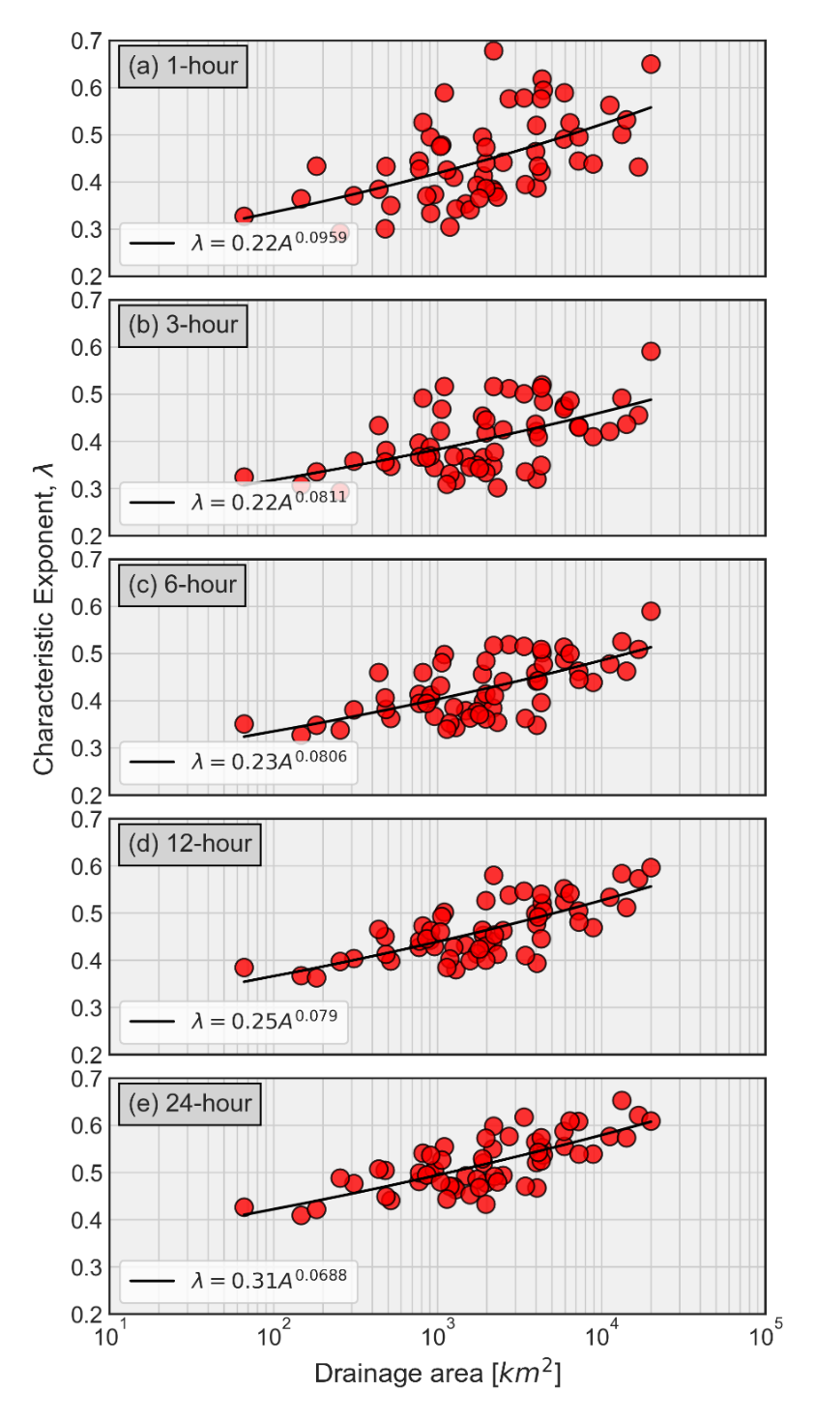
Figure A3: Spatial dependence of λ across five timescales obtained from averaging of 15-minutes raw streamflow data. (a) 1-hour, (b) 3-hour, (c) 6-hour, (d) 12-hour, and (e) 24-hour. The averaging of raw streamflow data across timescales demonstrates that with the increasing time scales, the relationship of λ with basin size does not show much variability. Clearly, the prominent change is in the smaller basin size, where streamflow process shows transitions from chaotic to stochastic behavior with increasing timescales.

Area ~ 500 km² | Area ~ 16, 800 km²
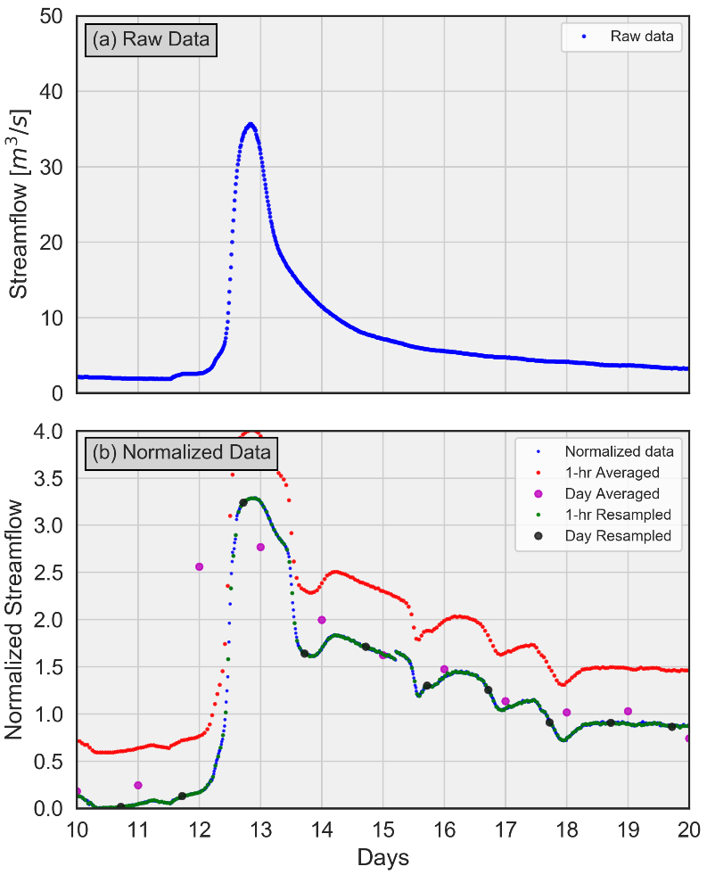 | 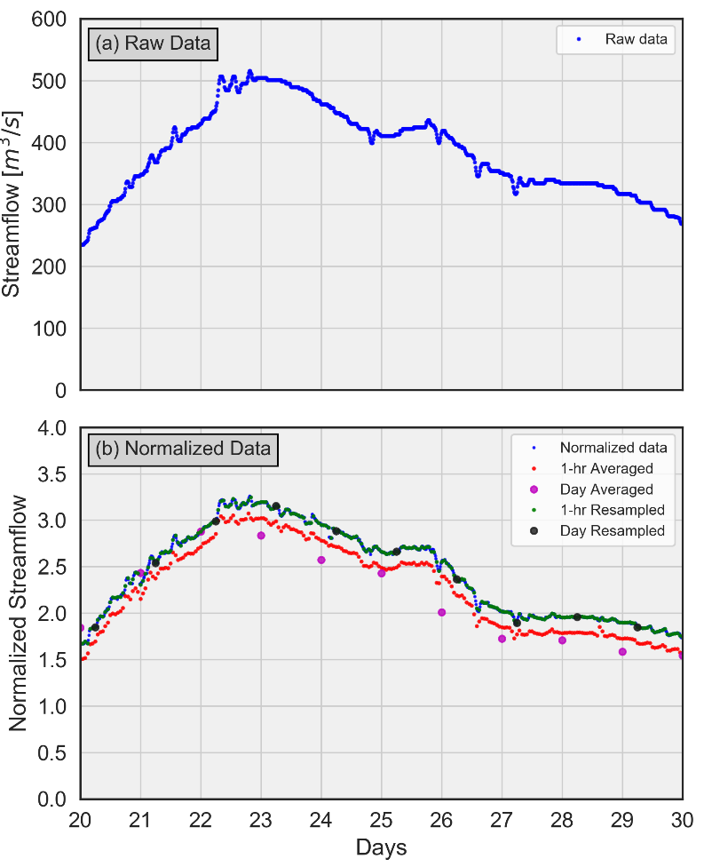
Figure A4: Demonstration of averaging and resampling of 15-minutes resolution streamflow data for two basin sizes. First column shows raw streamflow data (a) and normalized data (b) for basin size of 500 km², while second column shows raw streamflow data (a) and normalized data (b) for basin size of 16, 800 km². Comparison between these two scales clearly demonstrates the prominent effect of averaging and normalization (standardization) on underlying dynamics.

